System to Track Training Participation

# Revision

Version 4

11/15/21 9:13 AM

# SME

Garth Scheidemantel

# Abstract

This document describes the process to track the participation in cybersecurity training.

# Group / Owner

Security / Cyber Instructor

# Motivation

This document is motivated by the need to have a system in place to track the cybersecurity training participation of individuals involved in creation of safety-critical, cyber-physical systems for certification of compliance to standards such as **ISO 21434** and **ISO 26262**.

# License

This work was created by **Motional** and is licensed under the **Creative Commons Attribution-Share Alike (CC4-SA)** License.

[**https://creativecommons.org/licenses/by/4.0/legalcode**](https://creativecommons.org/licenses/by/4.0/legalcode)

# Overview

It is insufficient to have security training without a corresponding training tracking as tracking is the metric by which training maturity is measured. The corporate training system is used to track the training progress for all employees.

The following workflow shows the training tracking system implementation:

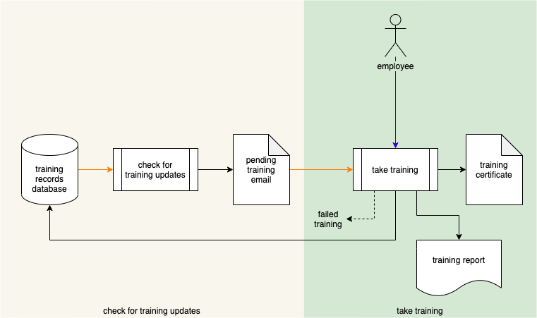

# Training Process

## Check for Training Updates

|  |  |
| --- | --- |
| **Inputs** | Training Records Database |
| **Outputs** | Pending Training Email |
| **Participants** | **None** |

The **Check for Training Updates** process monitors the **Training Records Database** and notifies employees as training modules become available or due. A **Pending Training Email** is sent to inform employees of these updates.

Notification types include:

* New training available
* Training coming due
* Training overdue

**Note:** Notifications will also be sent when training modules need to be retaken.

## Take Training

|  |  |
| --- | --- |
| **Inputs** | Pending Training Email |
| **Outputs** | Training Report  Training Certificate |
| **Participants** | Employee |

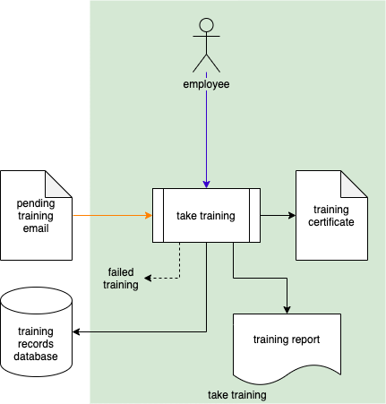

Upon receiving a **Pending Training Email**, the employee takes the training. A **Training Report** will be generated upon completion. The **Training Records Database** is updated based on the outcome of the training.

When the training includes a knowledge review and the employee fails to achieve the minimum passing score, a **Failed Training** notification is generated, and the employee is required to retake the training.

Upon successful completion of the training the employee is issued a **Training Certificate**.

# Reporting Process

## Employee Training Progress

|  |  |
| --- | --- |
| **Inputs** | Training Records Database |
| **Outputs** | Training Progress Report(s) |
| **Participants** | Manager or Employee |

The manager or employee accesses the **Training Records Database** and generates a **Training Progress Report**.

**Note:** The report query may generate multiple reports.

**Note:** The employee access is limited to their own training records.

# References

1. **Training Catalog** (AVCDL secondary document)
2. **Training Report** (AVCDL tertiary document)
3. **Training Progress Report** (AVCDL tertiary document)